**Programs on Interface**

1. **Write a program to implement following inheritance: Assume suitable methods.**

Interface: Sports

Member Variables:

Sport_wt=5, void show ()

Class Name: Student

Member Variables: Roll_no,name

Class Name: Result

Member Variables: marks1, marks2, total_marks, per,

Calpercentage()

1. **Write a program to implement following inheritance: Assume suitable methods.**

Class Name: Student

Member Variables: rollno, name, void input (),

void output ()

Interface: Employee

Member Variables:

B_SALARY, HRA, DA,

void show ()

Class Name: Manager

Member Variables: M_id, totalSalary

void CalculateSalary()

**1.Write a program to implement following inheritance: Assume suitable methods.**

**import** java.util.*;

**class** Student

{

**int** rollno;

String name;

Student(**int** a,String b)

{

rollno=a;

name=b;

}

}

**interface** Sports

{

**final** **int** ***sport_wt***=5;

**void** show();

}

**class** Result **extends** Student **implements** Sports

{

**int** mark1,mark2;

**double** per;

Result(**int** a,String b,**int** c,**int** d)

{

**super**(a,b);

mark1=c;

mark2=d;

}

**void** Calpercentage()

{

per=((mark1+mark2)*100)/200;

}

**public** **void** show()

{

System.***out***.println("Name:"+name);

System.***out***.println("\nRoll No:"+rollno);

System.***out***.println("\nPercentage:"+per);

System.***out***.println("\nSports Weight:"+***sport_wt***);

}

}

**class** Main

{

**public** **static** **void** main(String[] args)

{

// **TODO** Auto-generated method stub

Result ob=**new** Result(61,"Vishal",90,96);

ob.Calpercentage();

ob.show();

}

}

**OUTPUT:**

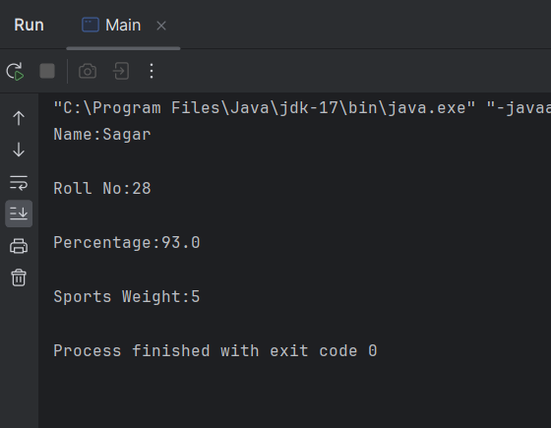

**2.Write a program to implement following inheritance. Assume suitable methods.**

**import** java.util.Scanner;

**class** Student

{

**protected** **int** rollNo;

**protected** String name;

**void** input()

{

Scanner sc=**new** Scanner(System.***in***);

System.***out***.println("Enter the Name:");

name=sc.next();

System.***out***.println("Enter the Roll no.:");

rollNo=sc.nextInt();

}

**void** output()

{

System.***out***.println("\nName: " + name);

System.***out***.println("\nRoll No: " + rollNo);

}

}

**interface** Employee

{

**double** ***B_SALARY*** = 50000; // Base salary

**double** ***HDR*** = 10000; // House Rent Allowance

**double** ***DA*** = 8000; // Dearness Allowance

**void** show();

}

**class** Manager **extends** Student **implements** Employee

{

**int** M_id=1001;

**double** totalSalary;

**void** calculateSalary()

{

totalSalary = ***B_SALARY*** + ***HDR*** + ***DA***;

}

**public** **void** show()

{

System.***out***.println("\nManager ID: " +M_id);

System.***out***.println("\nTotal Salary: " + totalSalary);

}

}

**class** Main

{

**public** **static** **void** main(String[] args)

{

Manager m= **new** Manager();

m.input();

m.output();

m.calculateSalary();

m.show();

}

}

**OUTPUT :**

